AEPES

Semester 1 Examination, 2024


Question/Answer Booklet

Students, please place your name in this box

Time allowed for this paper
Reading time before commencing work: Ten minutes
Working time for paper: Two and a half hours

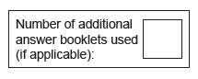
Materials required/recommended for this paper
To be provided by the supervisor
This Question/Answer Booklet
Multiple-Choice Answer Sheet
Extended answer booklet (lined paper)

To be provided by the candidate
Standard items: pens (blue.black preferred), pencils (including coloured), sharpener, correction fluid/tape, eraser, ruler, highlighters
Special items: non-programmable calculators approved for use in the WACE examinations

Important note to candidates
No other items may be taken into the examination room. It is your responsibility to ensure thatyou do not have any unauthorised notes or other items of a non-personal nature in the
examination room. If you have any unauthorised material with you, hand it to the supervisor
before reading any further.

Structure of this paper

Section | Number of questions available | No. of questions to be attempted | Suggested working time (minutes) | Marks available
Section One:  Multiple-Choice | 20 | 20 | 20 | 20
Section Two:  Short Answer | 9 | 9 | 70 | 65
Section Three:  Extended Answer | 3 | 3 | 60 | 30
 |  |  | Total | 115

SECTION ONE: MULTIPLE CHOICE (20 marks)

Record an answer for questions 1 – 20 by marking your choice on the separate Multiple-Choice Answer Sheet using a blue or black pen or a B or 2B pencil. Each question is worth one mark.

If you make an error, follow the instructions given to you on the Multiple-Choice Answer Sheet.

Suggested working time for this section is 20 minutes.

- Which of the following muscles produces extension at the elbow?

- Deltoids
- Biceps
- Quadriceps Group
- Triceps

- The tibialis anterior muscle contracts to cause which of the following movements
of the ankle joint?

- Pronation
- Dorsi flexion
- Plantar flexion
- Rotation

- Which blood vessel would only carry deoxygenated blood?

- Vena cava.
- Aorta.
- Pulmonary vein.
- Capillaries.

- The insertion point for the hamstring muscle is located on the:

- Tibia.
- Patella.
- Humerus.
- Tarsals.

- Which of the following is not a function of the skeletal system

- Attachment point for muscles
- Protects vital organs
- Storage of ATP
- Produces red blood cells

- Which of the following is not a function of the respiratory system

- Circulate blood around the body
- Provide a method for gas exchange
- Create speech
- Facilitate sense of smell

- Identify the correct labels:

- A – deltoid, B – gastrocnemius, C – radius, D – tarsals
- A – pectoral, B – soleus, C – ulna, D – metatarsals
- A – trapezius, B – tibialis anterior, C- ulna, D – tarsals
- A – pectoral, B - tibialis anterior, C – radius, D - metatarsals
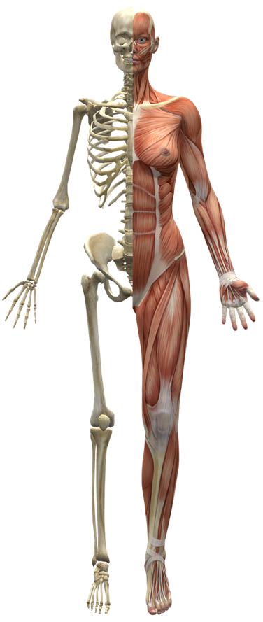



A
D
C
B

- Which of the following are both an immediate response and a long-term adaptation to exercise?

- Increased stroke volume
- Increased blood flow to the muscles
- Increased arterial – venous O₂ difference
- All of the above

- The predominant energy system utilised during a one-minute, 400m in athletics would be

- Lactic acid system
- ATP – PC system
- Aerobic system
- Interplay of all 3 systems

- The primary food fuel for energy production during high intensity activity is

- PC
- Protein
- Fats
- Carbohydrates

- For an athlete to increase muscular strength, he/she should:

- Use heavy weights with many repetitions
- Use light weights with many repetitions
- Use heavy weights with few repetitions
- Use lights weights with few repetitions

- In the sport of rugby, the ball carrier has to react to the defence quickly, often changing his initial running direction. This is a characteristic of which component of fitness?

- Muscular strength
- Agility
- Muscular power
- Flexibility

- Which of the following is not an immediate response to exercise?

- Increased respiratory rate
- Increased blood pressure
- Decreased resting heart rate
- Decreased creatine phosphate stores

- The amount of air inhaled or exhaled with one breath is referred to as:

- Respiratory rate
- Stroke volume
- Gaseous exchange
- Tidal volume

- Overloading the body during training can be achieved by varying three factors:

- specificity, intensity, reversibility
- intensity, frequency, duration
- intensity, duration, recovery
- time, frequency, specificity
- A pre-season training session involves football players taking part in a modified form of continuous training, involving regular changes of pace in response to naturally occurring obstacles, such as hills. This training type is defined as

- resistance training.
- circuit training.
- Fartlek.
- plyometrics.

- The gaseous exchange occurs during respiration to allow oxygen to be exchanged for the carbon dioxide which has been returned from the body. Where does this exchange take place?

- in the nasal cavity, whilst the cilia filter out the unwanted waste gas
- at the base of the trachea, in the two major branches of the bronchi
- in the diaphragm as it contracts and relaxes to create pressure differential to allow
the exchange to take place
- in the microscopic air sacs called alveoli, at the end of the bronchioles

- Carbohydrates, fats and proteins play an important role in the production of ATP production. Which of the following statements is/are true?

- carbohydrates are the primary fuel sources and are stored in the muscles as glycogen
- protein is used as a fuel source in extreme circumstances, for example in ultra- marathons
- carbohydrates can last for over four hours without replenishing
- a and b

- With reference to muscle contraction, which of the following statements is the most accurate?

- attachment points allow a muscle to push and pull
- muscle attachment at the stationary end of the bone is called the origin of a muscle
- muscle attachment at the moving end of the bone is called the origin of a muscle
- muscle attachment at the stationary end of the bone is called the insertion point of
a muscle

- High Glycaemic Index (GI) food sources are most appropriate for athletes to:

- provide muscles with a rapid source of energy immediately prior and during competition.
- provides muscles with a means to recover, repair and grow
- improve efficiency of the aerobic energy system during short intervals.
- provide muscles with a sustained release of energy during competition.

END OF SECTION ONE

SECTION TWO: SHORT ANSWER (65 MARKS)

There are eight questions in this section. Attempt all questions.

Write your answer in the space provided. If room is insufficient, complete the question on the pages provided at the back of this booklet. Ensure that you clearly identify each answer.

Suggested working time for this section is 70 minutes.

Question 1 (5 Marks)

In the space provide draw and label a human heart.

Question 2 (3 marks)

Briefly explain the different factors that make gas exchange in the lungs possible.

Question 3 (9 marks)

(a) Insert labels for the three types of blood vessels indicated in diagram. (3 marks)

(b) Compare and contrast the structure of all THREE (3) of these vessels. (6 marks)

Question 4 (6 marks)

Gymnasts, in order to avoid injury, train by stretching their muscles beyond normal resting length.
This increases the muscles extendibility.

Identify and define the three other characteristics of skeletal muscle.

Question 5 (4 marks)

In a swimming race, an athlete will breathe in causing the diaphragm and intercostal muscles to contract. Describe the mechanics of inhalation, when breathing during swimming.

Question 6 (12 marks)

Below is an image of a soccer player preparing to kick a ball.

- Label the two muscles labelled A and B in the box provided. (2 marks)
- Label the insertion point and origin point of muscle A on the diagram. (2 marks)
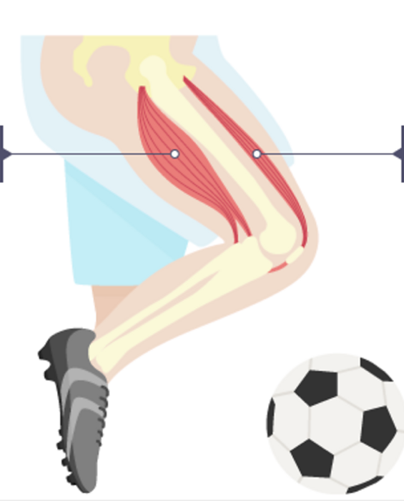

A ____________________
B ____________________

- Define the terms origin and insertion (2 marks)

- Muscles work in pairs to create movement. Explain how the muscles on the front and back of the thigh work together to create movement to flex the knee in preparation to strike the ball. (4 marks)

- Describe the two movements that occur at the ankle joints when kicking. (2 marks)

Question 7 (11 marks)

Athletes rely on the efficiency of their circulatory system to carry oxygen and nutrients around the body to all the cells, whilst removing waste products and carbon dioxide.

- Blood is the main fluid in the circulatory system. Identify the four components found in the blood and outline their main function. (8 marks)

- As an athlete begins their training session, several immediate, physiological responses occur in the body and the athlete will begin to experience an increase in body temperature. Account for the increase in temperature experienced by the athlete and describe how the body prevents overheating. (3 marks)

Question 8 (9 marks)

CrossFit has recently become a popular recreational training activity for personal fitness. The CrossFit Games incorporates a variety of demanding exercises which require different training methods and muscular contractions.
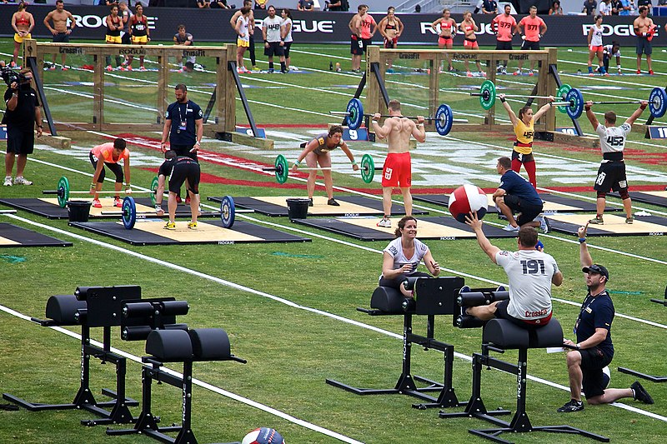

- Explosive movements can often cause injuries to soft tissues such as ligaments, tendons and muscles. Define which training method should be incorporated to lower the risk of injury and provide an example for a CrossFit athlete. (3 Marks)

- Training programmes should incorporate specificity (type) and progressive overload to place stress upon the athlete’s physiological systems, causing adaptations.

Outline three (3) other principles that any athlete can adjust as they adapt. (6 marks)

Question 9 (6 marks)

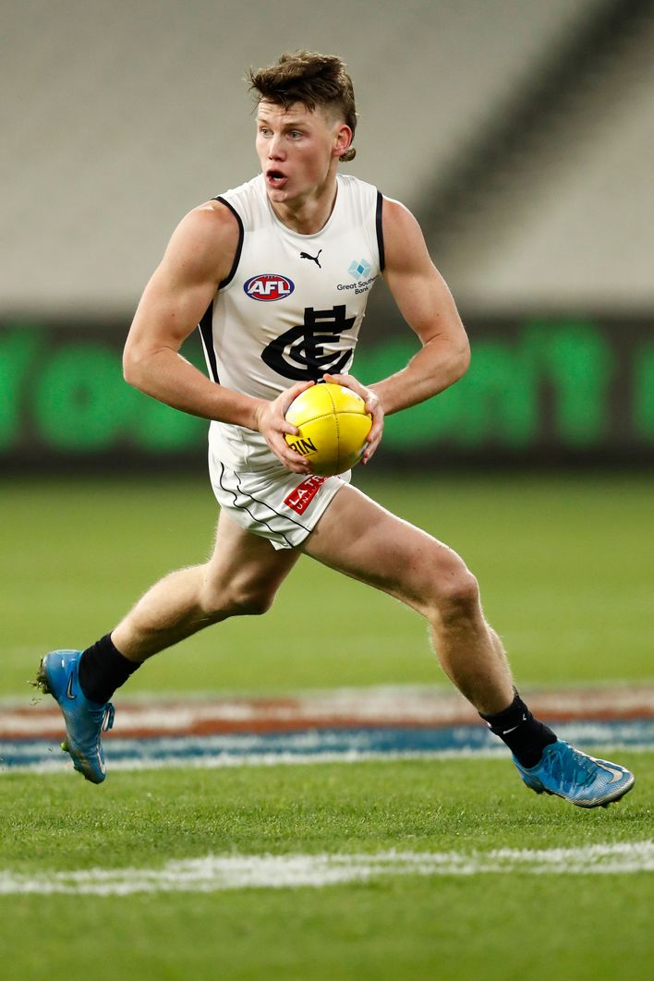

AFL is a highly demanding sport with some elite players running up to 15 kilometres in a game. Identify and describe three (3) immediate responses of the respiratory system as a player is running around the field.

END OF SECTION TWO
SECTION THREE: EXTENDED ANSWER (30 MARKS)

There are three questions in this section. Attempt all questions.

Write your answers on the lined pages provided. Ensure that you clearly identify each answer.

Suggested working time for this section is 60 minutes.

Question 10 (10 marks)

Mathieu van der Poel is an outstanding cyclist having won the World Cyclo-Cross Championship on five occasions. His aerobic capacity allowed him to make a seamless transition to road cycling, where he won the World Road Race Championship in 2023 across a distance of 273km over 6 hours.

Explain how oxygen enters the circulatory system and the pathway it takes to Mathieu’s working muscles and then the pathway to removing carbon dioxide from the lungs.
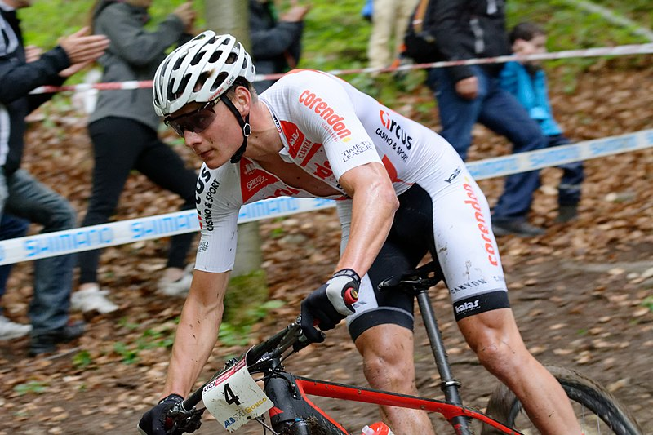

Question 11 (10 marks)

The Busselton Ironman Triathlon consists of a 3.8km open water swim, 180km cycle and 42.2km run. Elite athletes can complete the course in 8 hours, whilst amateurs can take up to 16 hours to cross the finish line.

Explain how an ironman triathlete will nutritionally fuel and hydrate themselves prior and during the race to optimise their performance.

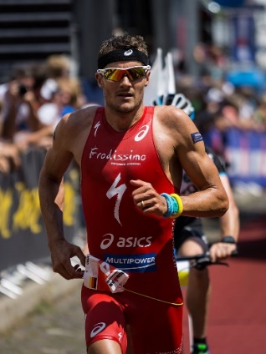

Question 12 (10 marks)

Damian is a State grade touch football player, competing for the Southern Stars Touch Football team. At the State grade level, a game of touch football consists of two 20 minute halves. There are six players per team on the field at one time. Also, regular substitutions after approximately two minutes on the field are a critical part of the game at this level.

- Discuss the advantages and disadvantages of each of the body’s energy systems.
(7 marks)

- Use the energy system continuum to explain how the body’s energy systems are utilised during the game.
(3 marks)

